**Section 2.2—More on Functions and Their Graphs**

A function is increasing if it generally rises from left to right.

A function is decreasing if it generally falls from left to right.

A function is constant if it does not change from left to right.

A function can increase over an interval and decrease over another interval, meaning that one function can be both increasing and decreasing.

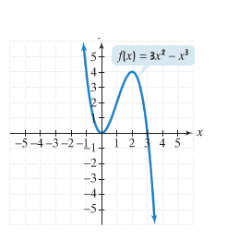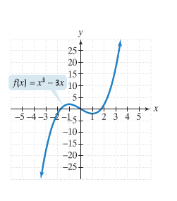**Example**—State the intervals on which the given function is increasing, decreasing, or constant.

The points where a function changes from increasing to decreasing and vice versa are called the relative maximum and relative minimum.

**Example**—Find the relative minimum and relative maximum in the first graph from the example above.

A function is an **even function** if $f\left(-x\right)=f\left(x\right)$ for all x in the domain of $f$.

* The right side of the equation of an even function does not change if x is replaced with –x.

A function is an **odd function** if $f\left(-x\right)=-f\left(x\right)$ for all x in the domain of $f$.

* Every term on the right side of the equation of an odd function changes its sign if x is replaced with –x.

**Example**—Determine whether each of the following functions is even, odd, or neither.

$f\left(x\right)=x^{2}+6$

$g\left(x\right)=7x^{3}-x$

$h\left(x\right)=x^{5}+1$

**Piecewise Function**: A function that is defined by two (or more) equations over a specified domain

**Example**: A cell phone company has the following plan: $20 per month for 60 minutes and $0.40 for each additional minute. To write an equation, let C represent the monthly cost and t the number of minutes.

$C\left(t\right)=\left\{\begin{aligned}&20 \\ &20+0.40\left(t-60\right)\end{aligned}\right.$ $if0≤t≤60$ $$ift>60$$

Find each of the following:

$C\left(30\right)$

$C\left(100\right)$

$C\left(40\right)$

$C\left(80\right)$